USER MANUAL WEB Based Utility of Superannuation Contribution
- Login to https://www.licindia.in

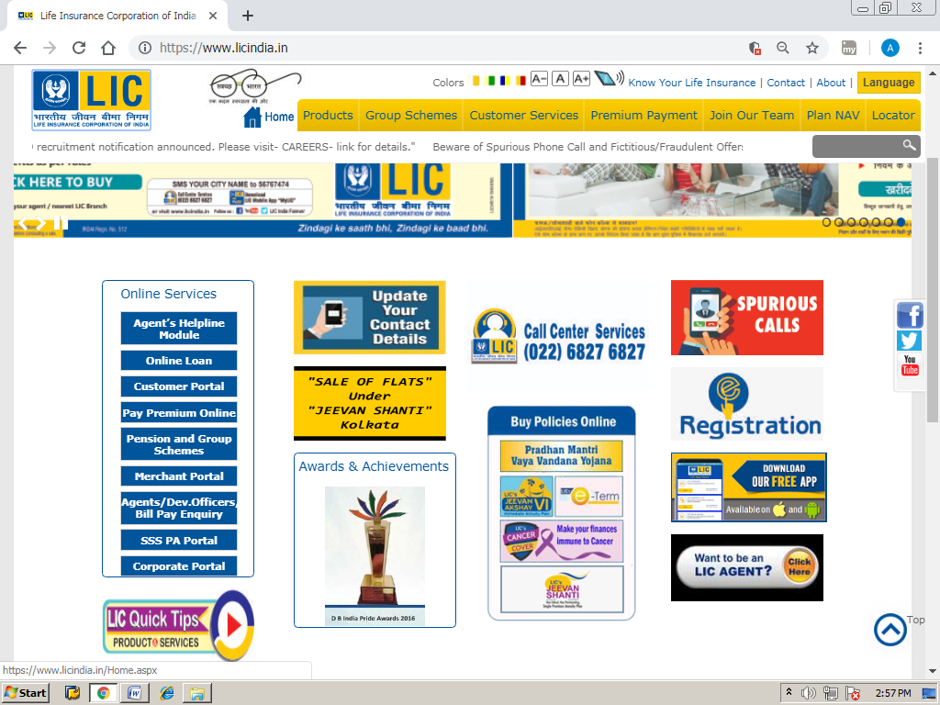

- Go to the Link in the extreme left tab “ Pension and Group Scheme” (refer to the Arrow above)

- Click on the link “ Click here for Enrolment”
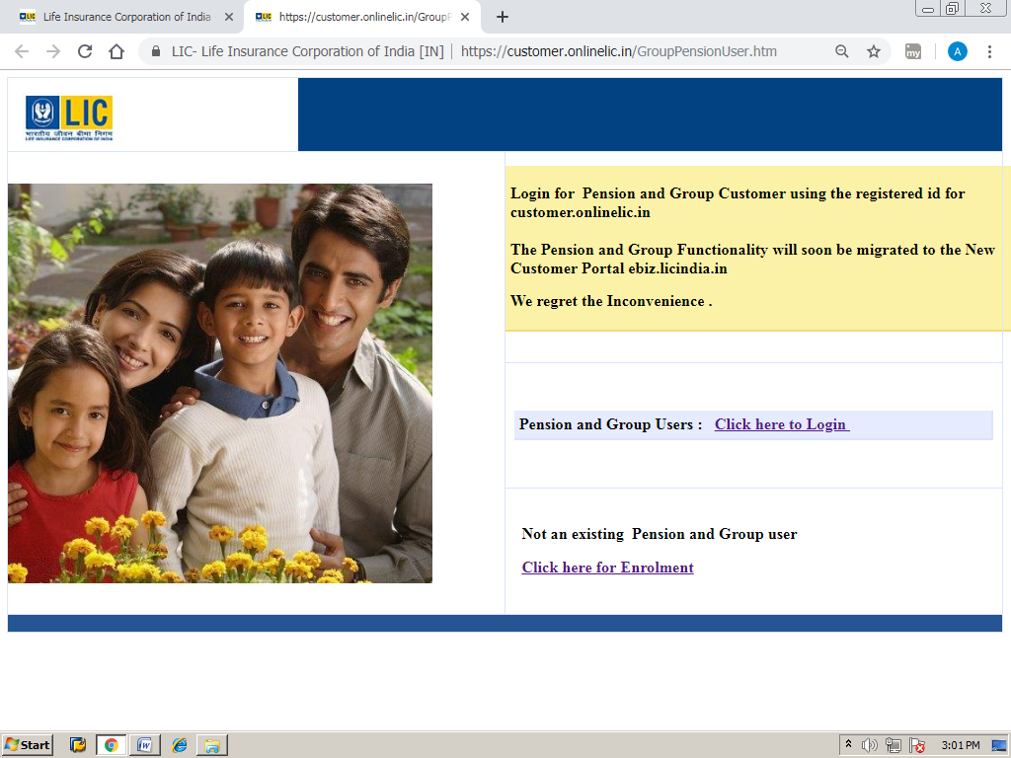

- Enter Policy No. 103004833 and click in the Check Box of Members
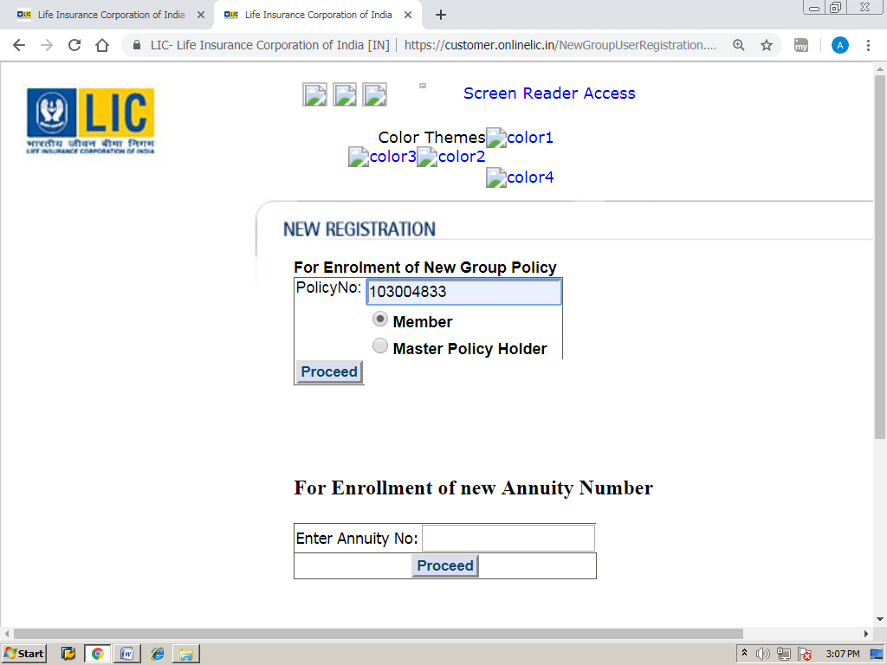

- Entre your LIC ID (Will be mentioned on Pay Slip) and Date of Birth and Proceed.

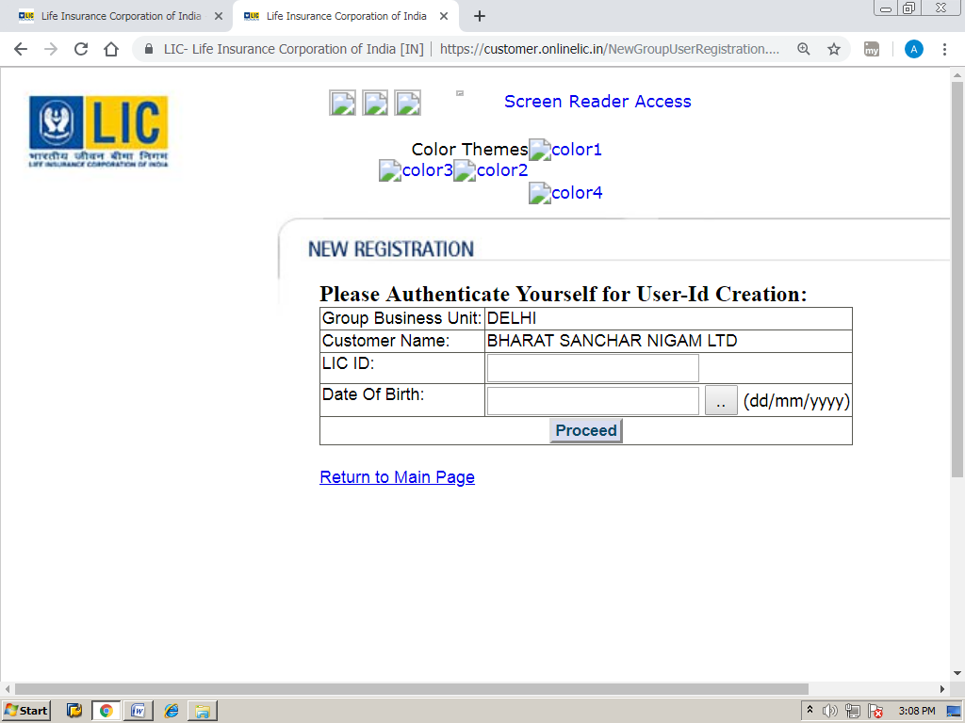

- Create User ID and Password of your own choice and Submit.

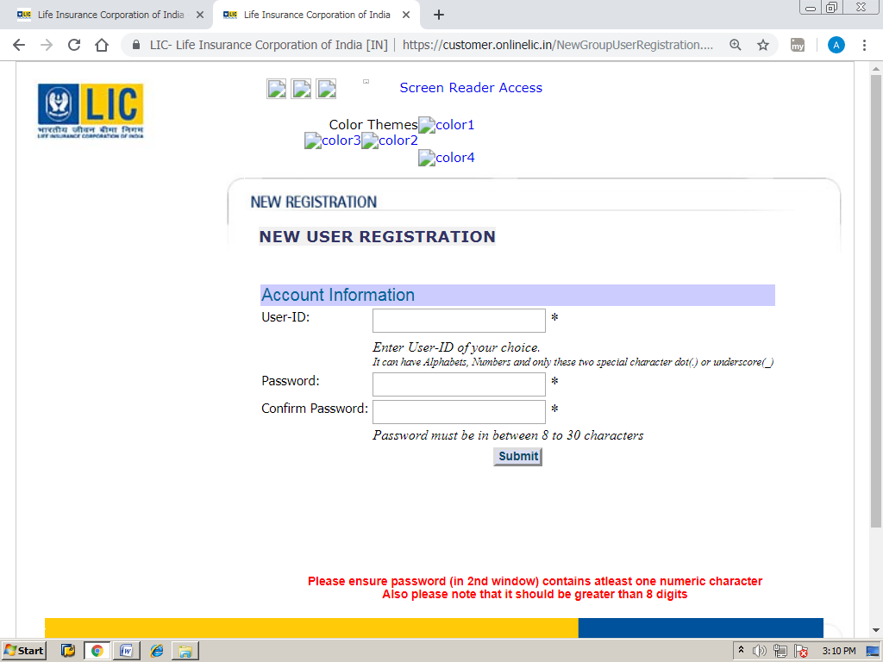

- Click on the Group Scheme Details, refer the arrow given below.
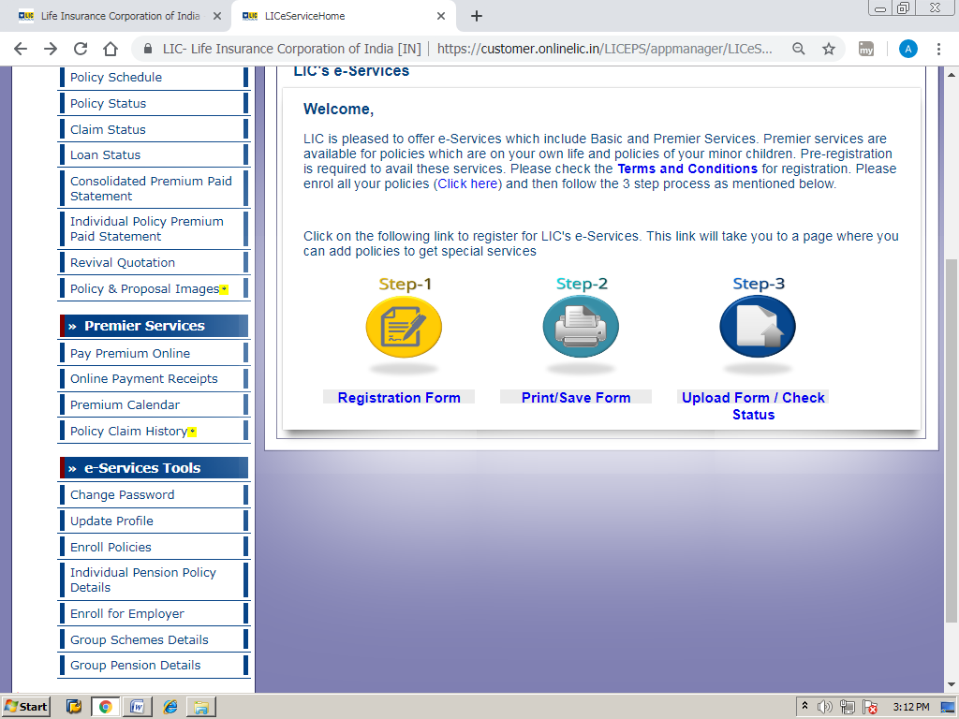

- By Clicking the Policy Number the details of Policy will appear on the Screen.
- Further details may be seen by Clicking on the highlighted Policy Number.

